Ideation Phase
Brainstorm & Idea Prioritization Template

Date | 31 January 2026
Team ID | LTVIP2026TMIDS88360
Project Name | Civil Engineering Insight Studio
Maximum Marks | 4 Marks

Step-1: Team Gathering, Collaboration and Select the Problem Statement

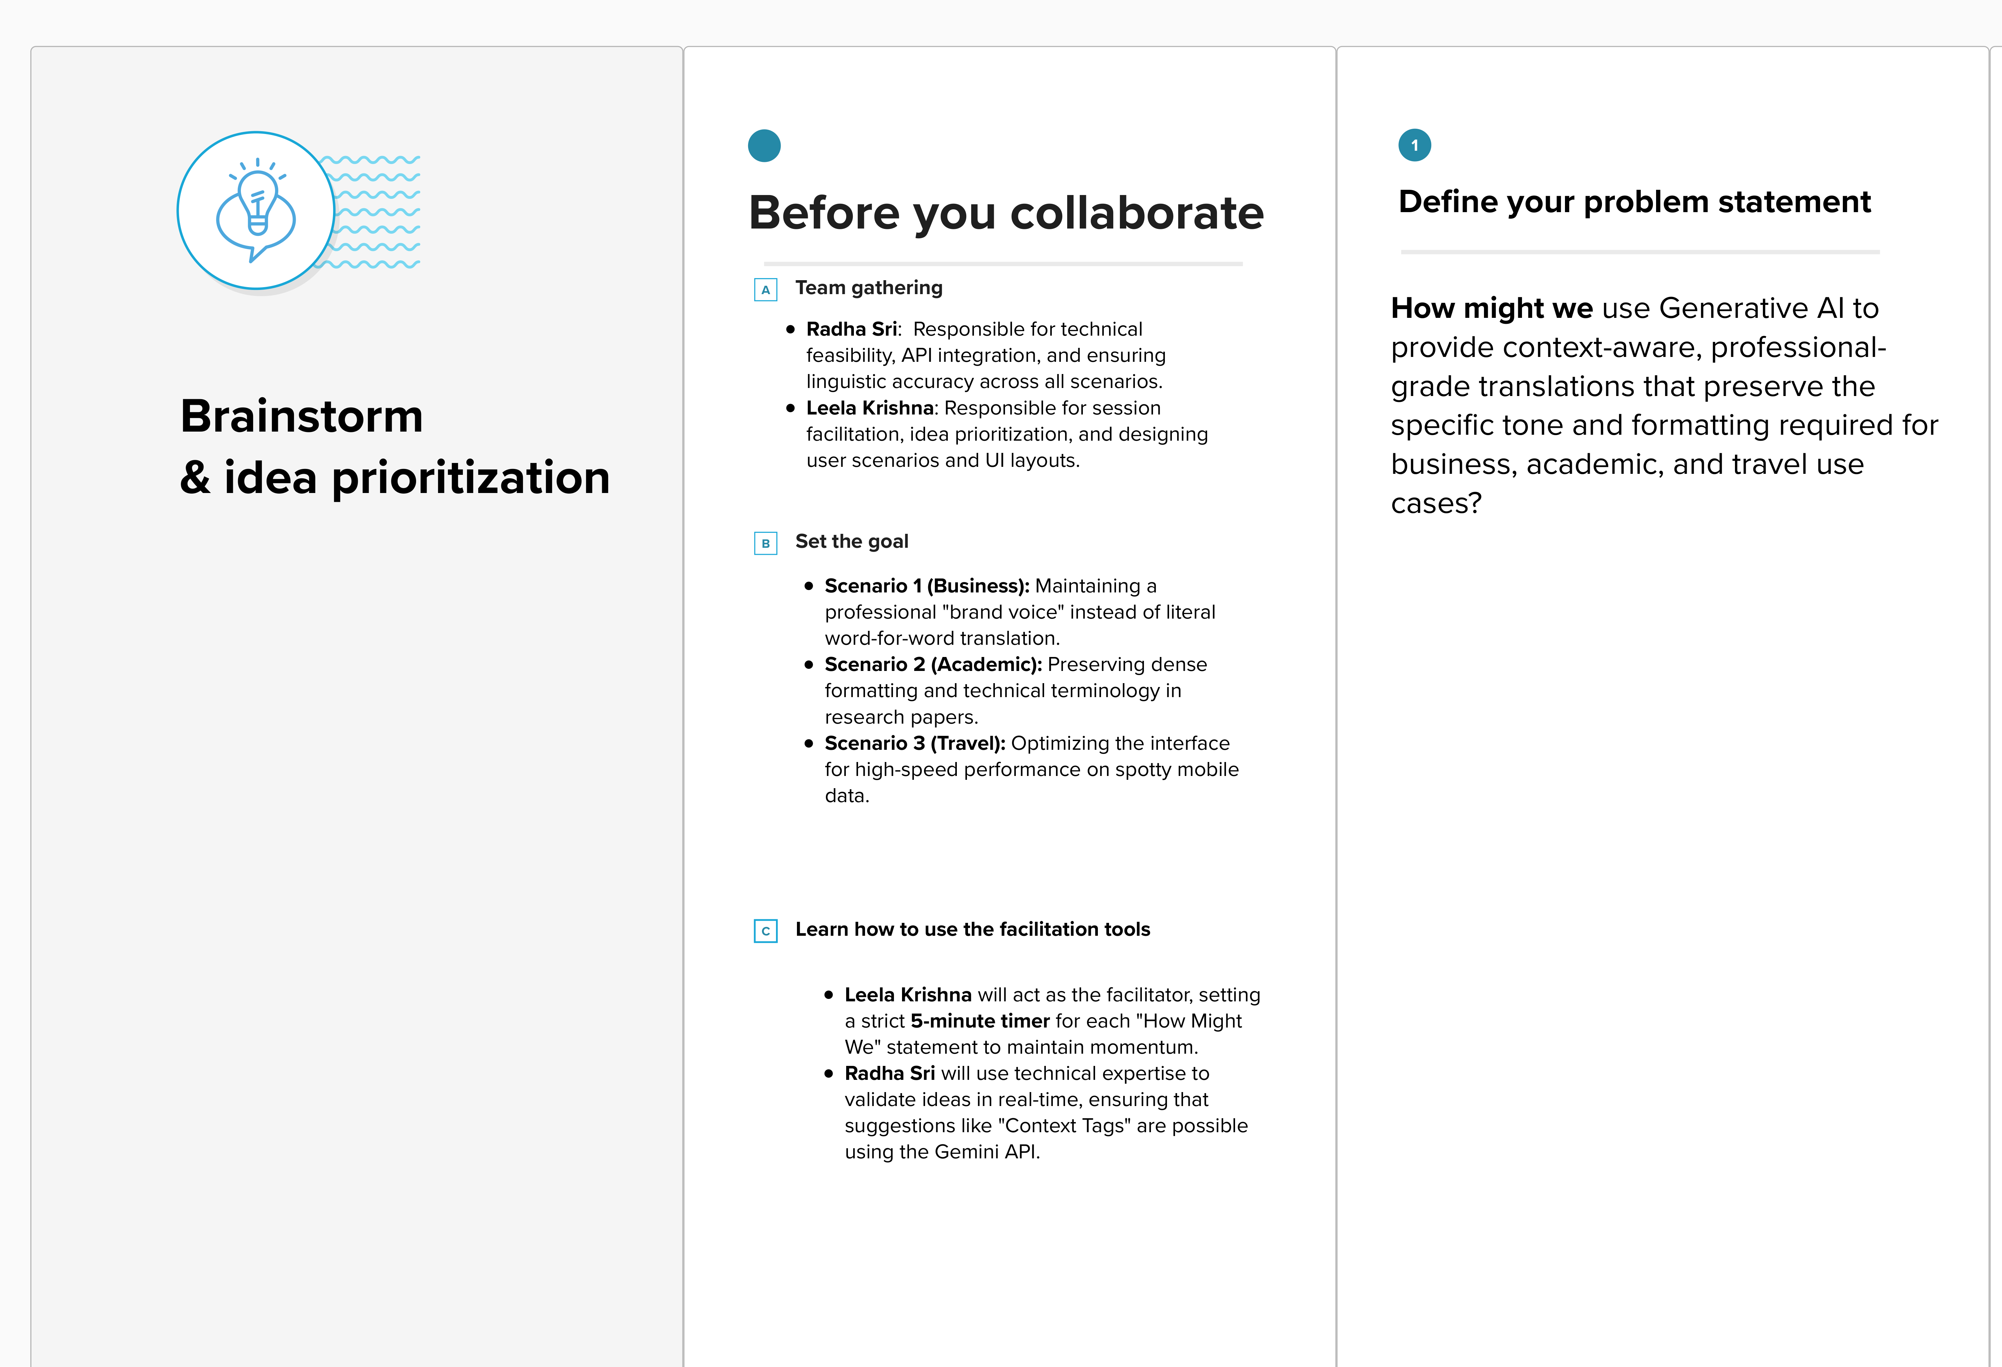

Step-2: Brainstorm, Idea Listing and Grouping
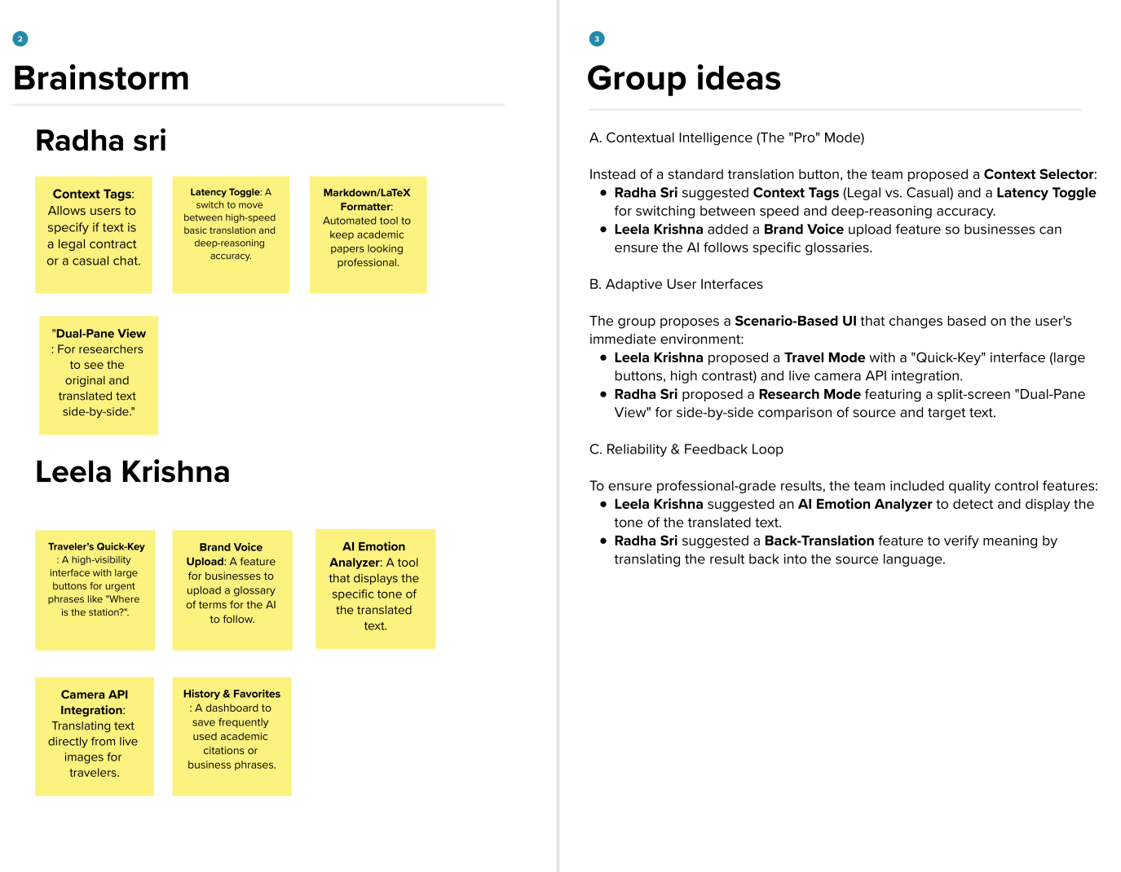
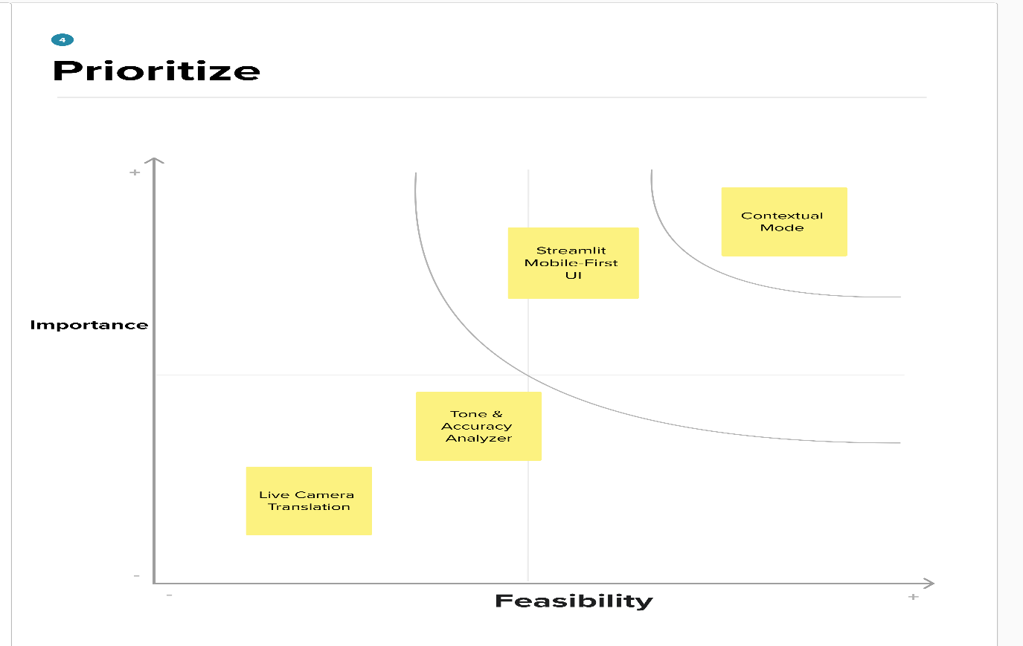
Step-3: Idea Prioritization

